PACKET TRACER PROJECT

Question a-)Network Devices = Switch ,Router , Computer , Server and Hub.

There is a connection that connects these devices(cables).

IP ADDRESS = The address used by devices connected to the internet or any other computer network to sende data to each other over the network.

Switch = Key means device . It transmits by establishing a path between the device sending the data and the receiving device.

Router =Network hardware that provides the connection between multiple networks. That is, it enables routing of computers connecting to the networks.

Computer = The main purpose of the computer is to collect and share information from the user.

Server = Server is a generic name given to computer units on computer Networks that are accessible to clients(users) , running resources open to use and sharing or some services.

Hub = It is one of the network connection devices without administrative features used for data connection between connected devices.

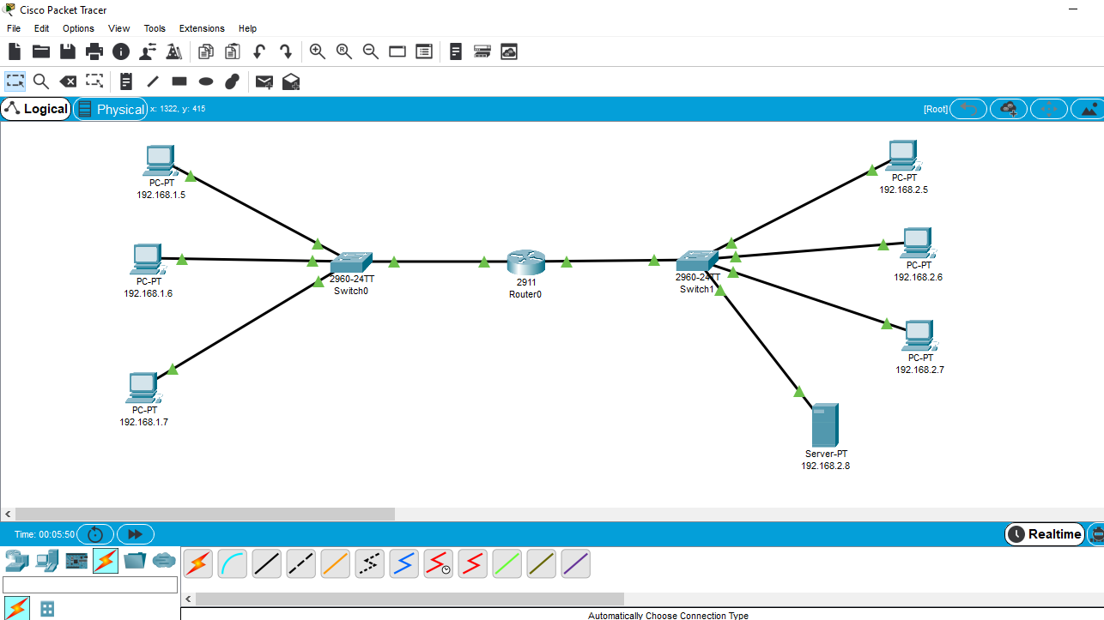

Question b- )It can be defined as the reaction time in ping connections . In other words,Ping measures the time that your existing data goes to another computer and comes back.We have calculated the time from 192.168.1.6 to 192.168.1.7. 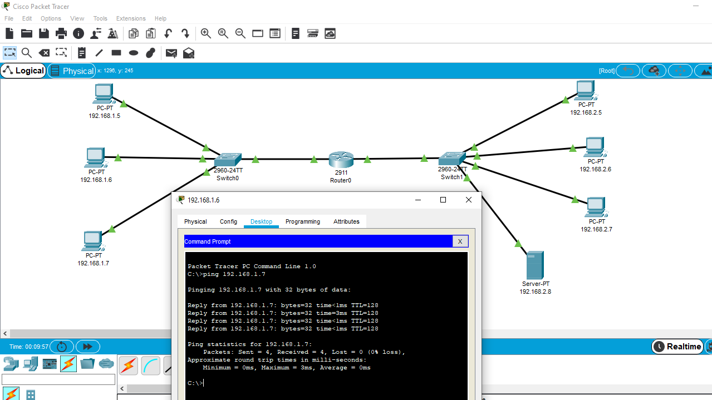

Question c-)ICMP = When the TTL expires , it assumes duties such as notifying the owner of the package , providing feedback on the package destroyed in any case , providing feedback in error occurences and providing feedback when the package will go the other way.

---Numbers are the ways I did when finding ICMP.

---1- ) This is the indicate ip address . The ip address where the message is written.

---2- )This is the destination ip address. The message was sent here.

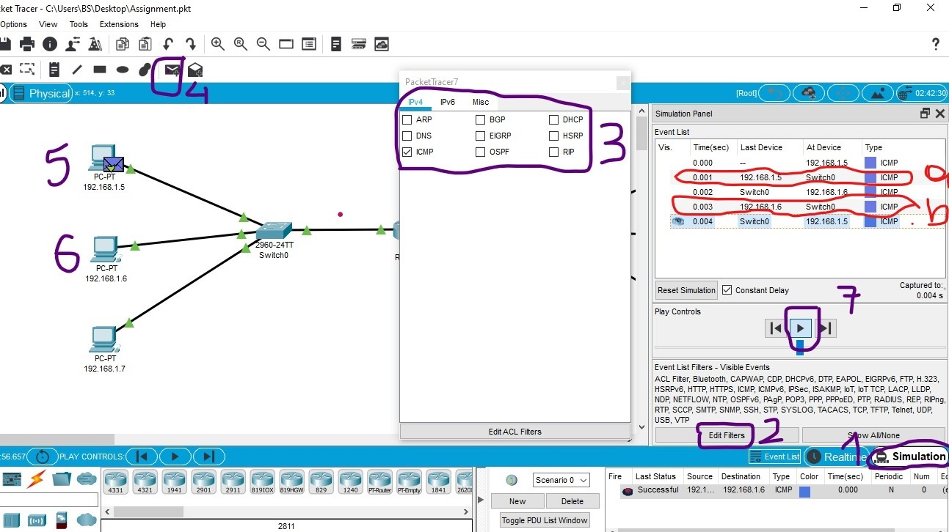

Question d-)This is the we connection I made from the same network as the server=

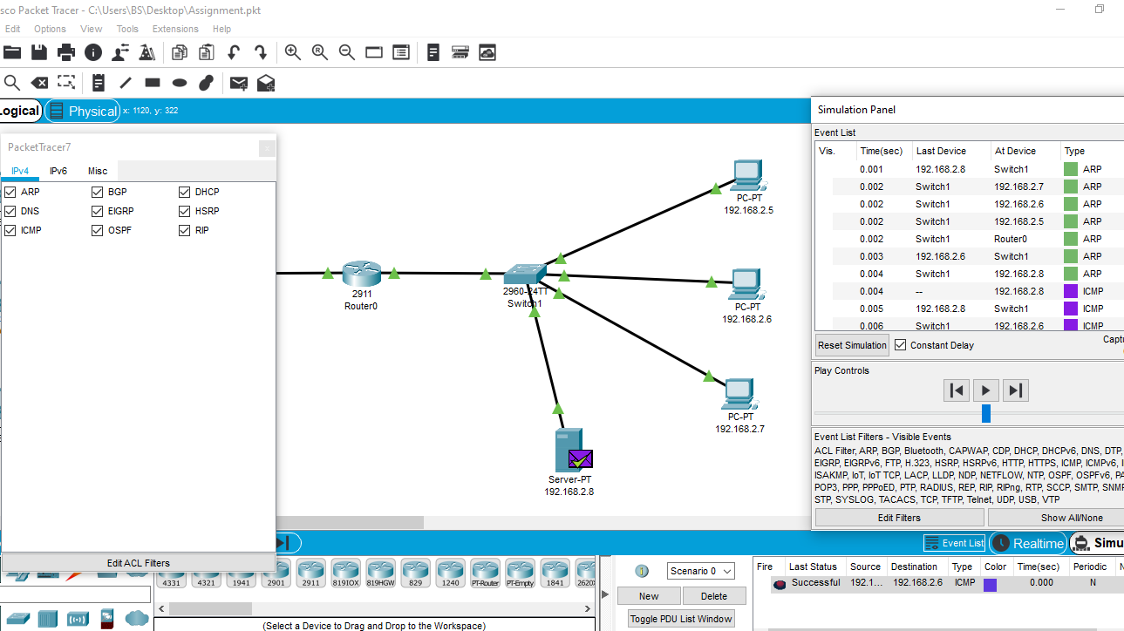

This is web connection with the server from the other network=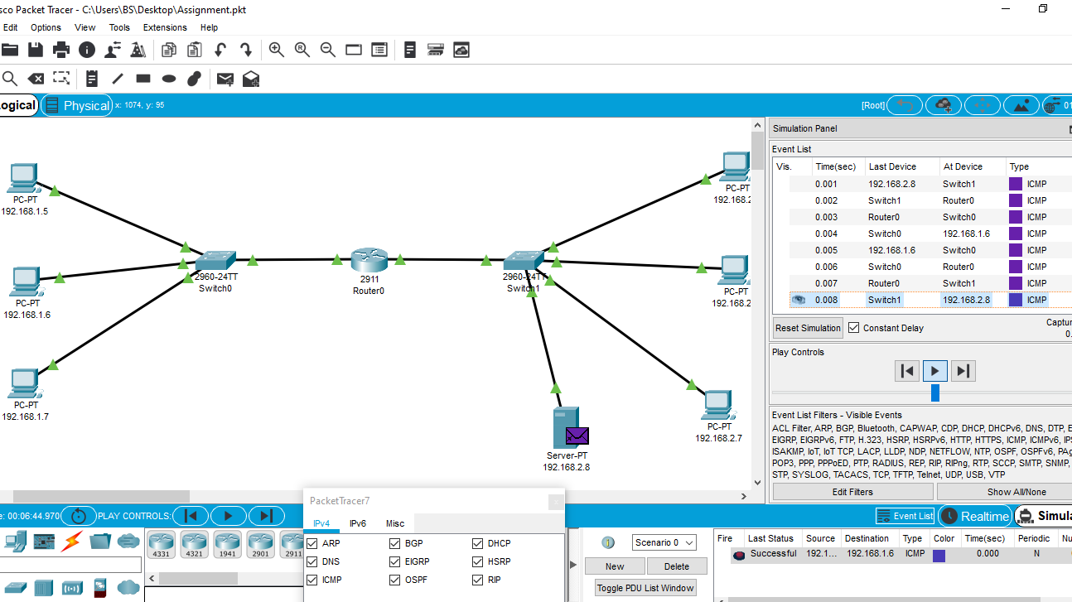

--- Every computer has an IP address and so it is known where to go.

---When we sending each message , it is sent with packages. For instances , ICMP,ARP,DNS,DHCP…

---When we sending , it shows where there is an error and finds the ip address it should go to.

---Here it shown how long the messages will arrive at the correct ip address.

---Here the message also shows router , switch or computer when the message is running.

Question – e)This picture shows multiple connections on the same network =

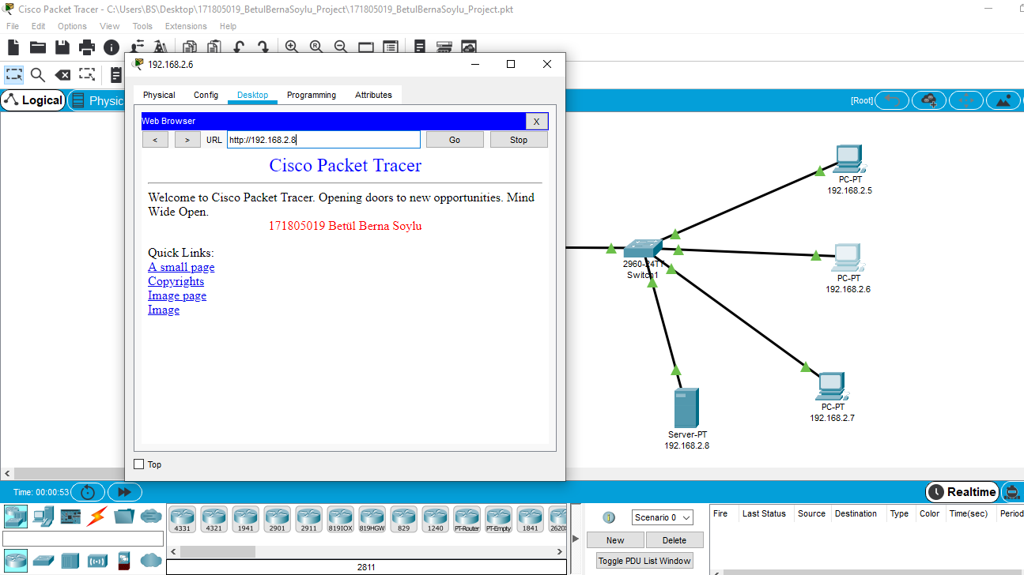

This picture shows multiple connections on the orher network =

